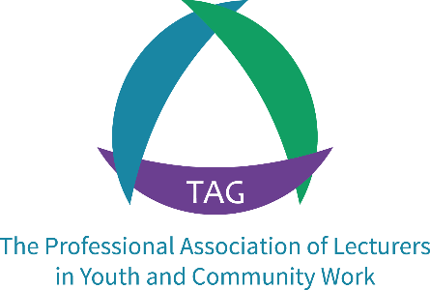

Annual Conference 2021
Reflection, Recovery and Regeneration
Learning from the lived experiences of the Covid-19 pandemic
11th-12th November 2021, 10.30am-4.30pm: Online via Zoom

Call for Contributions: Closing date Friday 17th September 2021
As we emerge from multiple lockdowns and contemplate the catalyst for change that is inevitable post-pandemic, there continue to be unanswered questions about what higher education, youth work, and community development will be facing in the weeks, months and years ahead. This year’s online conference provides an opportunity for Association members and our wider network to pause and reflect on the impact of the pandemic as we construct a new normal. Conference will include discussion of how pedagogical approaches to education in youth and community work are challenged by the re-shaping of Higher Education after two years of interrupted learning and shifts towards digitally-led pedagogy. The future also presents particular challenges and opportunities for youth and community work as a distinct professional practice as we seek to recover and regenerate in our work with young people and their communities. Furthermore, it is clear how the pandemic has highlighted the health, wealth and social inequalities across society and the ‘patterns of change’ that appear to repeat themselves at times of national crisis. Conference will explore these questions through seminar presentations, research dissemination and group discussions that share emerging practice, debate emerging realities and plan for future collaboration in addressing these changes.
Our emphasis - as with all annual conferences - will be on dialogue, discussion and debate as we reconvene to refresh our commitment to youth and community work education in as we emerge from the Covid-19 pandemic. Contributions to the seminar programme are invited through completing the form on the page that follows. We are inviting contributions to the three conference themes that embrace a breadth of learning, practice and research activity that has been taking place throughout lockdown:
- Reflection: We invite contributors to present reflections on the policy and practice of teaching youth and community work in higher education: its challenges, opportunities and future possibilities.
- Recovery: We invite contributors to present on how practice is adapting and responding to the inequalities exposed by Covid-19; and the role of youth and community work in building back fairer.
- Regeneration: We invite contributors to offer perspectives from research that articulate the patterns of change in youth and community work, historically (what we can learn from the past) and presently (what we are learning from lived experiences during the pandemic) and what comes next?
There is an open call for contributors on these themes that address theory, research and educational practice. Abstracts are invited using the proposal form (see next page) and the deadline for abstracts is 17th September 2021. Contributors will be informed by Friday 1st October of your contribution to the programme.
Any questions about presentations or participation in the event can be directed to: hello@tagpalycw.org
An abstract, maximum of 200 words, is requested those that wish to make presentations.
Presenters will normally be offered a maximum 15 minute slot for presentations followed by a chaired breakout room where the issues will be discussed by conference delegates.
You can also volunteer to facilitate (chair) a breakout room, act as a ‘chatbot’ for breakout rooms (typing up comments and questions); and a rapporteur on presenting back summaries from each breakout room discussion. A full brief will be provided for each role and minimal preparation is required.
Contributors Proposal: Annual Conference 2021
Name:
Email Address:
Phone contact:
Institution/Agency:
Contributing Role:  (Please tick all that apply) | Facilitator/Chair: |  |  | Chatbot/Notetaker:
 | Rapporteur: |  |  | Presenter:
If Presenter,
please add a title:
Proposed Stream:  (Title may apply to more than one) | Select Here: | Conference Seminar Theme (where there is a preference):
 |  | Reflection
 |  | Recovery
 |  | Regeneration
Abstract or Description
(max. 200 words)

Process for submission and confirmation of approved contributions:
Submissions will be considered by a panel from the Association’s Directors. Allowing for any clarifications, contributors will be notified in by Friday 1st October with further instructions for online contributions.

Please return this form to hello@tagpalycw.org by Friday 17th September 2021

